Ditributed system project

By Franck Cussac and Mathis Detourbet

Jean-Michel Busca

I – Global registry

With the native RMI, when a client wants to use a remote object, he needs to know the address of the server which can send him the stub of this object. It makes problems with the anonymous requirement. That what we need, is a system where the client is already requesting the same server which can redirect him to the server which hosts the right service.

So, we will create a server that we will call the global registry. The global registry will save all the server’s stubs, and the client will be able to request it to find his service.

The object GlobalRegistry extends Registry. On this new object, we will override the methods bind, Registry. rebind and lookup. For each bind, we want that the GlobalRegistry put the sended stub on a map. And for each lookup, we want that the GlobalRegistry return the right stub. For that, we need to add a Map<String, Remote> which will put each stub on the map at his service name position.

After, we need a function to create our GlobalRegistry. For a Regitry, there is the LocateRegistry class. But it’s a static object, so I can’t create an object which extends it. However I can clone it in a new class that I call LocateGlobalRegistry. I don’t need all the LocateRegistry’s methods, so I just duplicate createRegistry(), getRegistry() and getRegistry(String).
GlobalRegistry is like a server, so if a client wants to connect to him, I need to bind it on a Registry. So, firstly, on createRegistry(), I instantiate a Registry. After, I instantiate my GlobalRegistry. Because of my GlobalRegistry extends Registry, it’s a Remote object and I can bind it on my
Now the problem is, I don’t want that my client get the Registry when he requests it. It’s why I have to create a new getRegistry() and a new getRegistry(String). The client uses getRegitry(String). getRegistry() is just used by a server and calls getRegistry(String) with the default value “localhost”. Into getRegitry(String), I return a lookup on my registry to get the GlobalRegistry which is saved on my registry.

Now, what is new for the clients and the servers ? When they will get the registry to bind or lookup, they won’t use LocateRegistry.getRegistry(String) but the method that we have created : LocateGlobalRegistry.getRegistry(String).

Now it’s finished, we have implemented a GlobalRegistry.

II – Stateless service

For the example, our stateless service will be a Sorter. And that we want is a distributed system. It means that there is multiple servers for the same service, and each of them will work for the clients. We have chosen a round robin algorithm to distribute the work at each lookup.

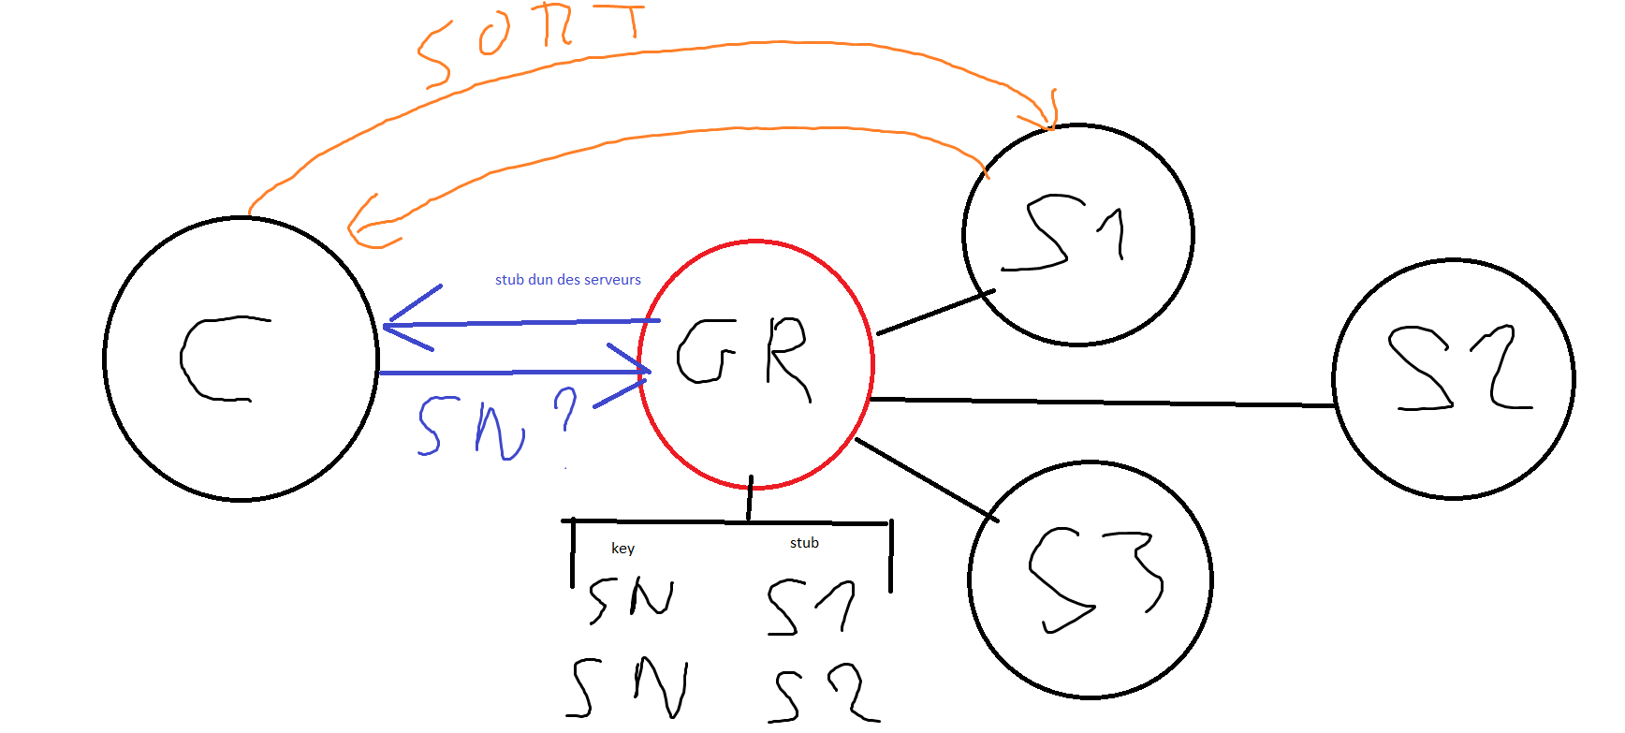
Here a schema of the architecture :
Firstly, we can see that if there are multiple servers for the same service, with the actual data structure, the GlobalRegistry can’t save them (in black behind the GR). We have to change the save of one stub for one service name for the save of one list on stub for one service name.
After, when a client asks to the GlobalRegistry “do you have this ServiceName ?” (blue arrows), the global registry must return one of the stubs that it has. And we don’t want the same at each client’s lookup. So we will add a handler on the list which will increment himself at each lookup. Don’t forget to loop at the end of the list. This handler can be an integer.
When the GlobalRegistry has returned a stub, the client talks directly with the owner of this stub when he requests a sort (orange arrows).

III – Statefull service

For the example, our statefull service will be a Repository.

1) Active distribution

For a statefull service, the distribution is harder. Each copy of the service must have the same value. The difficult is that each server must receive the request in the same order. To do it, we can create a first server which will communicate with the client and broadcast to the others servers each request. To be sure that the order is the same for every body, we can numerate each request and check with a counter if the request received is the right one.

After, we have to update the GlobalRepository. We need to add the management of a statefull service, which is different that the stateless service, on the same lookup method. For a stateless service, the distribution is round robin. For a statefull service, the client is connected to the same server and this server broadcasts to the others. So for a statefull service, the lookup method must return the first server of the server list.
To differentiate a statefull service to a stateless service, we have added a tag Istatefull and Istateless and we check with the keyword “instanceof”.

Now it stays to implement the broadcast. On the Repository object, we add a counter to check the order like we have seen. We add a new setProperty method too, which takes an additional integer, which is the number of the request.
On the setProperty(string, string), we get the server’s list for the same service and we call setProperty(string, string, int) for each of them.

2) Passive distribution

